Lunar University Network for Astrophysics Research
Annual Report to
Solar System Exploration Research Virtual Institute
January 22, 2014

Principal Investigator: Jack Burns, University of Colorado Boulder
Deputy Principal Investigator: Joseph Lazio, Caltech/JPL

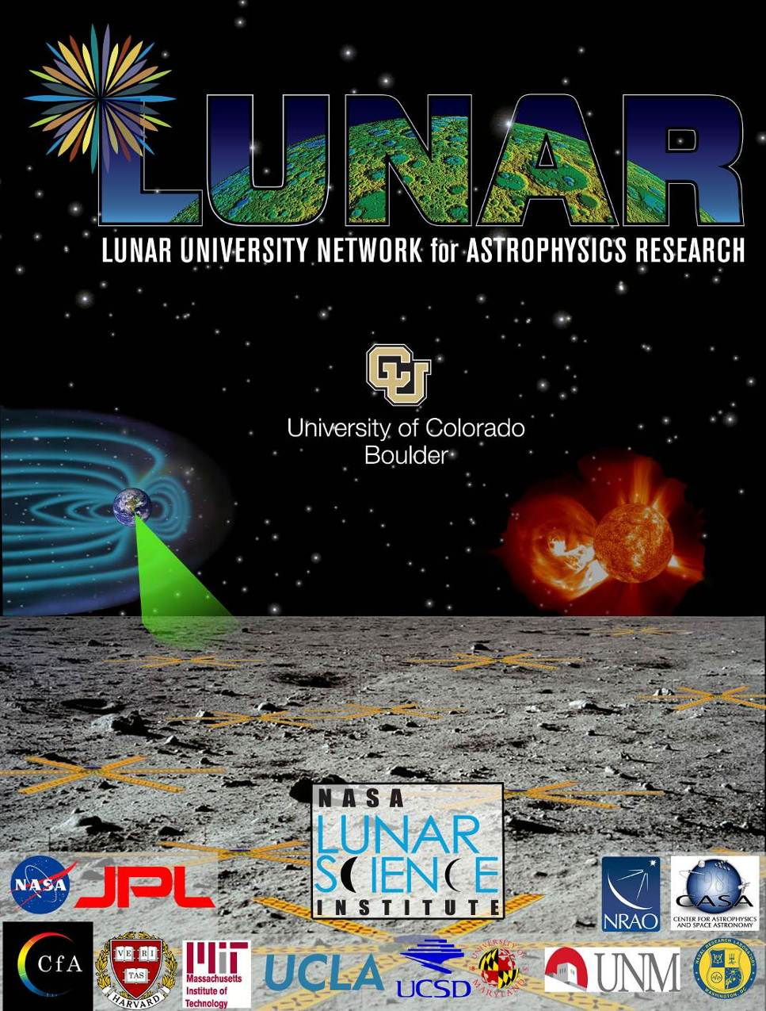

Overview of LUNAR

The Lunar University Network for Astrophysics Research (LUNAR) is a team of researchers and students at leading universities, NASA centers, and federal research laboratories undertaking investigations aimed at using the Moon as a platform for space science. LUNAR research includes Lunar Interior Physics & Gravitation using Lunar Laser Ranging (LLR), Low Frequency Cosmology and Astrophysics (LFCA), and Heliophysics.

Lunar Laser Ranging

Thermal/Optical Simulation of the Signal Magnitude Degradation for Apollo Retroreflectors

The magnitude of the return signal from the Apollo retroreflectors has been radically reduced over the decades. To create the optimal design of the LLRRA-21¹, we need to understand the origin of these effects and incorporate design modifications in order to minimize the effect of these phenomena. Over the past few years, a detailed Thermal/Optical Simulation has been developed for the LLRRA-21. Over the past year, these simulation programs have been modified and compared to the magnitude of the return signals as observed by the APOLLO station. The methods and the preliminary results have been the subject of several presentations. This research has involved collaboration with Giovanni Delle Monache of the INFN-LNF and Bradford Behr of the University of Maryland, College Park.
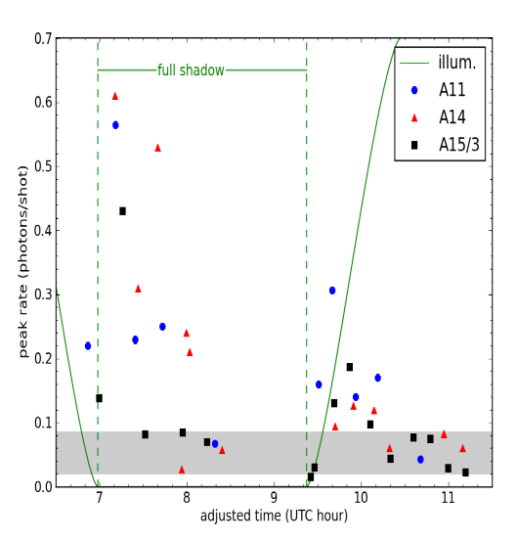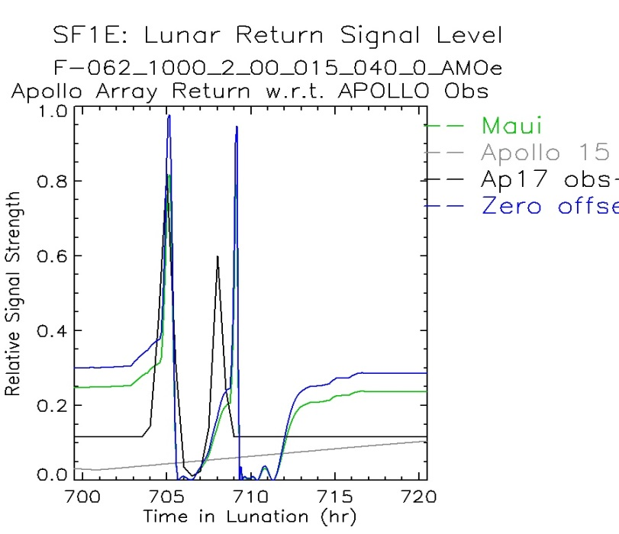
In the figure on the left are the observations by Co-I T. Murphy using the APOLLO station. In particular, due to the fact that the time constants of the changes in the solar illumination during a lunar eclipse are similar to the time constants for the Corner Cube Reflectors (CCR) and for the radiation exchanges of the housing, we can see dramatic effects in the magnitude of the return signal that tightly constrain the structure and parameters of the simulation. Note that shortly after the start of the lunar eclipse, the signal increases by approximately a factor of ten. It then drops to zero and then after the sun is again “on”, there is another very large peak. In the figure on the right is the current simulation, showing a similar pair of peaks. The parameters of the various thermal coatings are now being adjusted to improve the correlation, and thus to both validate the simulation programs and to learn current properties of the Apollo arrays after more than four decades of operation on the lunar surface.

Collaboration with INFN and ASI
A critical portion of the effort to develop and deploy the LLRRA-21 has been collaboration with INFN-LNF and ASI. To support this effort and to aid in obtaining funding for INFN, presentations have been made at INFN meetings and at INFN reviews of the INFN-LNF proposals. In addition, presentations have been made to ASI in support of the INFN-LNF proposals to obtain funds for the transport of the LLRRA-21 to the lunar surface.

Investigation of the Expected Improvement of the Science Results for 1 mm Ranging
While we may expect the LLRRA-21 will support 1 mm lunar laser ranging, thus improving the current single photoelectron ranging accuracy by more than a factor of ten, we need to evaluate the expected improvement in the various science parameters addressing lunar physics, gravitation and General Relativity. To this end, a collaboration has been established with Professor Jürgen Müller of the Institute of Geodesy Leibniz Universität Hannover. This simulation will determine the magnitude of the improvements and the time scale over which they will occur. This simulation is currently running and the results will be presented at the meeting of the European Geophysical Union in April 2014.

Corner Cube Reflectors (CCR) Fabrication and Interferometer Measurements
In the fabrication of the 100 mm CCR, angular and phase measurements must be made to an unpredicted accuracy. Tests conducted on a commercial interferometer unit to perform these measurements have been performed at the INFN Laboratory in Frascati. These measurements indicate that the systematic errors in the measurements are as large as ten times greater than the specified errors. This could lead to unaccepted errors in the CCR fabrication and greatly reduced lunar laser return signals. Research is continuing to determine the reasons for this phenomenon. Additional evaluation measurements will be performed on several other commercial units to find acceptable measurement procedures.

Investigation of Lunar Transport Capabilities
This effort involves strong interaction with various Google Lunar X Prize teams that could carry the LLRRA-21 to the lunar surface. This especially applies to the Moon Express and Astrobotics teams. Recently, initial contact has been established with the Israeli team. Due to limitations on the available mass on the Israeli lander, this will require a significant modification of the design and is thus requiring a new series of simulations to be developed.

Low Frequency Cosmology and Astrophysics (LFCA)

Theoretical Tools and Science Development

Co-I Furlanetto and his group have continued to study the implications of recent high-redshift galaxy observations and models for the earliest phases of star formation in the Universe. UCLA Graduate student Lauren Holzbauer has led an investigation into predictions for the cosmic near-infrared background through extrapolations of galaxy data at z<8. With galactic evolution models from postdoctoral researcher Joseph Munoz, she has shown that the data suggest that a strong near-infrared background requires massive changes to the efficiency or character of star formation. She has also developed a diagnostic of the mode of star formation through cross-correlating the backgrounds generated by hydrogen and helium recombination lines. Both of these complementary observations will help lift degeneracies in the 21-cm background at low radio frequencies. They will appear in a pair of papers to be submitted in early Spring of 2014. Meanwhile, Co-I Furlanetto has continued to explore analytic models for the so-called baryon-cold dark matter streaming effect (which have to date only been explored through expensive numerical simulations). These are important for the earliest phases of the low-frequency signal, dramatically affecting the pattern of first star formation.
Co-I Loeb studied with a visiting student, Anastasia Fialkov, the redshifted 21-cm emission by neutral hydrogen during and after the epoch of hydrogen recombination in the redshift range of z ~ 500-1100, corresponding to observed wavelengths of 100-230 meters. The 21-cm line deviates from thermal equilibrium with the cosmic microwave background (CMB) due to the excess Ly-alpha radiation from hydrogen and helium recombinations. The resulting 21-cm signal reaches a brightness temperature of a milli-Kelvin, orders of magnitude larger than previously estimated. Its detection by a future lunar or space-based observatory could improve dramatically the statistical constraints on the cosmological initial conditions compared to existing two-dimensional maps of the CMB anisotropies. The above long-wavelength signal was not calculated accurately before and it establishes an interesting target for a LUNAR observatory.
PI Burns with Colorado graduate student J. Mirocha and postdoc G. Harker performed new investigations of the sky-averaged (global) 21 cm signal which is a powerful probe of the intergalactic medium (IGM) prior to the completion of reionization. So far it has been unclear whether it will provide more than crude estimates of when the universe's first stars and black holes formed, even in the best case scenario in which the signal is accurately extracted from the foregrounds. In contrast to previous work, which has focused on predicting the 21 cm signatures of the first luminous objects, Mirocha et al. (2013) investigated an arbitrary realization of the signal and translated its features to the physical properties of the IGM. Within a simplified global framework, the 21 cm signal yields quantitative constraints on the Ly-α background intensity, net heat deposition, ionized fraction, and their time derivatives without invoking models for the astrophysical sources themselves. The 21 cm absorption signal is most easily interpreted, setting strong limits on the heating rate density of the universe with a measurement of its redshift alone, independent of the ionization history or details of the Ly-α background evolution.

Low Radio Frequency Science Instrument and Technology Development

Co-I Bowman and his Arizona State University (ASU) team of students and postdocs conducted laboratory tests of a prototype receiver front-end to characterize S-parameters and noise temperature (LOCO memo#33 and 35). Modifications to the reference front-end design were made to enable preliminary tests of alternative calibration switching schemes in order to provide a common reference for performance assessment of the system. ASU staff performed on-site testing and repairs in November of a low radio frequency engineering prototype at the Murchison Radio-astronomy Observatory in Western Australia and supported preparations for the next test deployment in Green Bank, WV. An ASU postdoc studied precision calibration techniques using Vector Network Analyzers (VNAs) in partnership with researchers at Haystack Observatory working on the EDGES experiment. This work resulted in a detailed error propagation model for VNA measurement of S-parameters and demonstration of achieved measurement precision better than 0.05 dB for a typical antenna. An ASU undergraduate investigated coupling between angular and spectral structure in global 21 cm measurements due to chromatic primary beam effects for a variety of antenna models, including the reference DARE antenna design. Journal articles describing the VNA techniques and chromatic beam effects are in preparation.

Co-I Carilli continued work with ground-based low frequency interferometers to study the cosmological signal from neutral hydrogren in the early Universe. This work is key preparatory work for a future low frequency radio telescope on the Moon, informing both the science and the techniques. These studies have the potential to become the 'richest of all cosmological data sets', with an impact on cosmology and studies of galaxy formation comparable to that of the

discovery of the Cosmic Microwave Background.

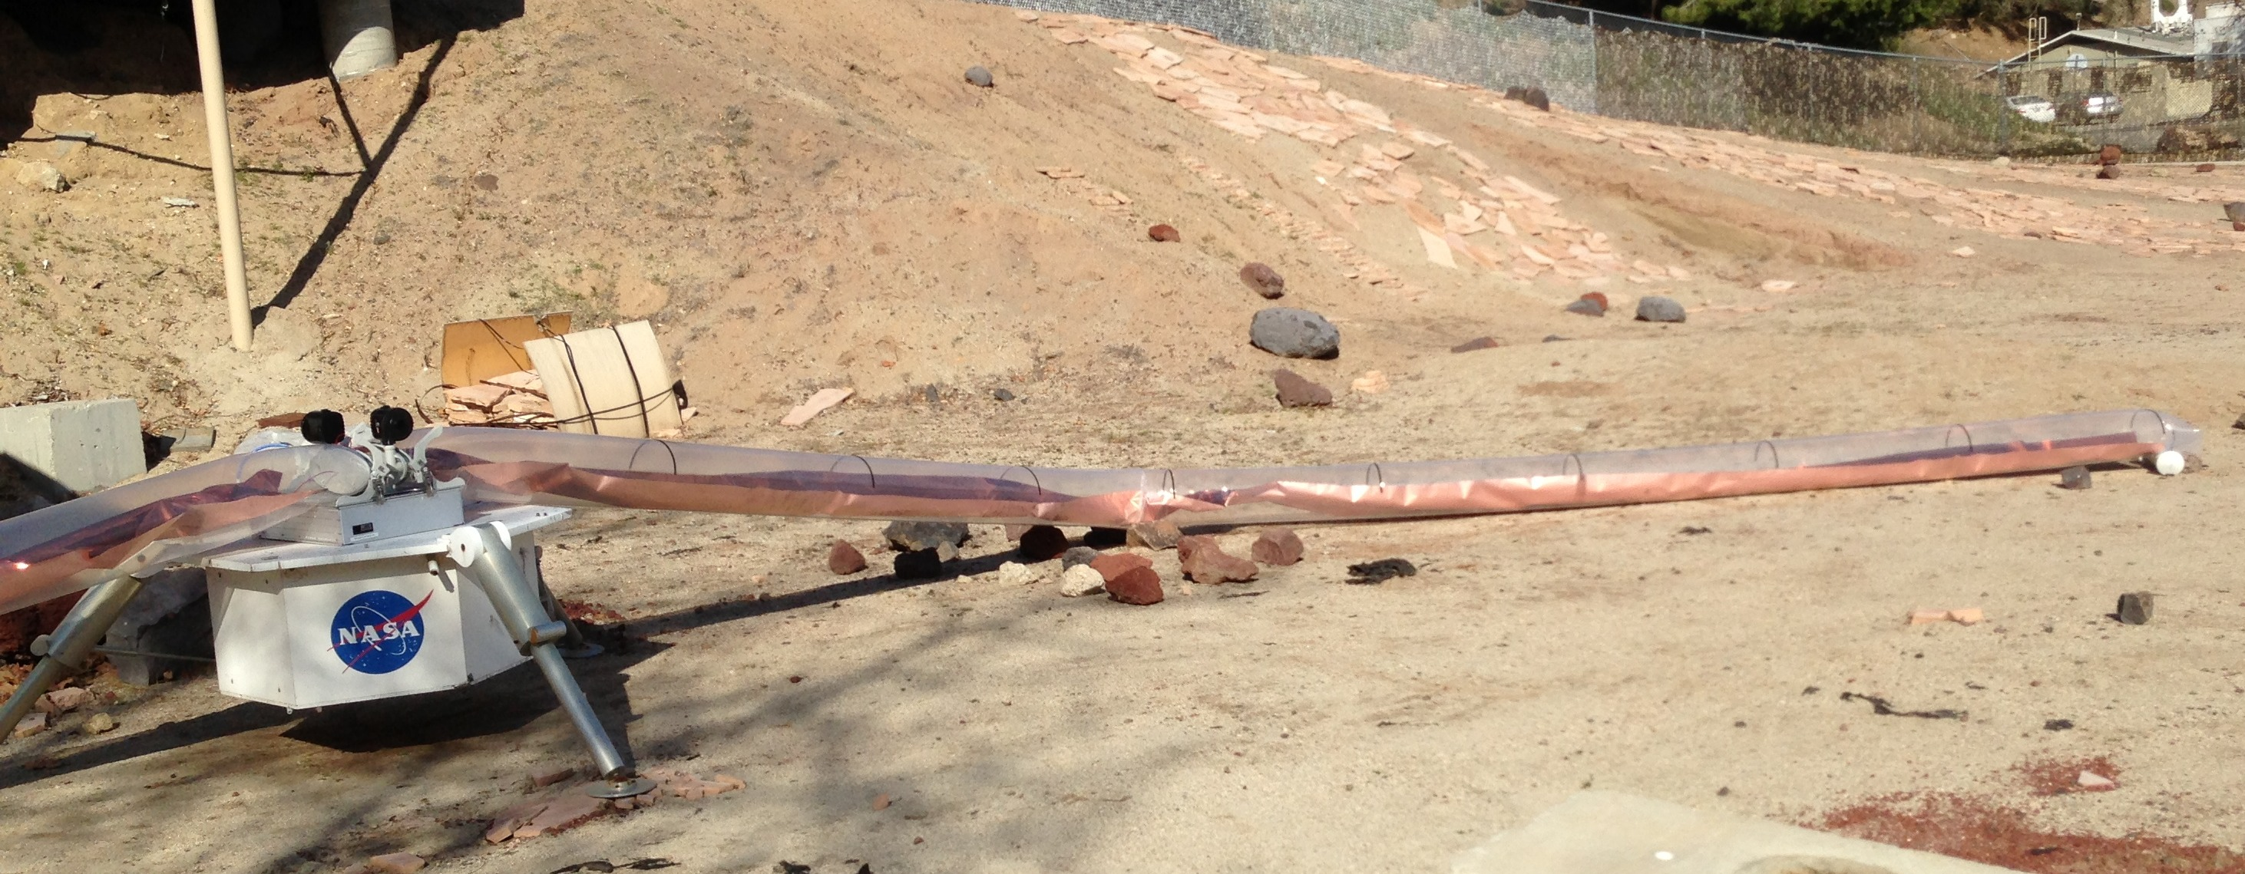
Proof-of-concept lunar surface antenna being deployed from a mock lander in the JPL Mars Yard. The antenna is encased in a plastic tube, which is being inflated to deploy the antenna. The approximate length of the arm is 10 meters.

The primary focus of Co-I Jones and Lazio has been the development of technologies for future lunar orbiter and surface missions designed to observe at radio frequencies below approximately 200 MHz. The science motivations for such missions are varied and range from lunar science, heliophysics, and astrophysics. Notable successes over the past year include the deployment of a lunar surface antenna from a mock lunar lander (see above) and the reception of high frequency (HF) band signals from a proof-of-concept instrument package consisting of an antenna and receiver. Specifically for the case of using a lunar surface radio antenna to probe the lunar ionosphere, we continued to refine the science case in light of conflicting results from spacecraft occultations and recent ARTEMIS observations of the Earth’s auroral kilometric radiation. Our preliminary conclusion is that there is sufficient uncertainty in the combined measurements that a lunar surface radio antenna could detect the lunar ionosphere and track its behavior in response to the solar wind.

PI Burns’ team at U. Colorado continued its work on the development of a ground-based engineering prototype of a mission concept (DARE) to detect the 21-cm global signal from the Dark Ages through Cosmic Dawn in collaboration with Co-I Bradley at NRAO. Colorado graduate student B. Nhan and NLSI/NASA postdoc A. Datta assisted Bradley in completing the re-design and fabrication of new bi-conical antennas. JPL has tested a balun for the prototype provided by NRAO and has returned it for deployment in Green Bank, WV. The goal of this prototype is to perform end-to-end verification of the science instrument, and to provide new constraints on the Earth’s ionosphere which drives this experiment to lunar orbit.

Colorado postdoc G. Harker working with Burns has completed code development of an updated affine-invariant Markov Chain Monte Carlo code that will be used to extract the 21-cm global signal in the presence of strong galactic and solar system foregrounds, also accounting for instrumental effects. This same code is being used to model the effects of the ionosphere which limit precise measurements of the global signal turning points as required to differentiate between different models of the first stars in the early Universe.

LUNAR Simulation Laboratory

Under the direction of PI Burns, the LUNAR Simulation Laboratory at Colorado is used to test the effects of the harsh lunar environment on materials and hardware. LUNAR team members used a newly constructed thermal-vacuum chamber that contains a bed of JSC-1 lunar simulant for a more realistic representation of the lunar surface. Copper-coated Kapton was thermally cycled for one month, with each 24 hour cycle representing a lunar day or night. The Kapton showed greater thermal variation than pieces tested in the original vacuum chamber, possibly due to the simulant regolith deforming with the Kapton and maintaining greater thermal contact than the aluminum table. The laboratory team also constructed a teleoperated mini-rover (called THOR), assembled from COTS components modified to be space-qualified, to experiment with deployment protocols in a simulated lunar environment and to better understand the limitations of the lunar environment.

Earth-Moon L-2 Mission Concept & Simulation using the ISS

PI Burns, Kring (LPI), along with Co-Is Lazio and Kasper developed a novel concept for a human mission to the lunar L2 (Lagrange) point that would be a proving ground for future exploration missions to deep space while also overseeing scientifically important investigations. In an L2 halo orbit above the lunar farside, the astronauts aboard the Orion Crew Vehicle would travel 15% farther from Earth than did the Apollo astronauts and spend almost three times longer in deep space. Such a mission would serve as a first step beyond low Earth orbit and prove out operational spaceflight capabilities such as life support, communication, high speed re-entry, and radiation protection prior to more difficult human exploration missions. On this proposed mission, the crew would teleoperate landers/rovers on the unexplored lunar farside, which would obtain samples from the geologically interesting farside and deploy a low radio frequency telescope. Sampling the South Pole-Aitken basin, one of the oldest impact basins in the solar system, is a key science objective of the 2011 Planetary Science Decadal Survey. Observations at low radio frequencies to track the effects of the Universe's first stars/galaxies on the intergalactic medium are a priority of the 2010 Astronomy and Astrophysics Decadal Survey. Such telerobotic oversight would also demonstrate capability for human and robotic cooperation on future, more complex deep space missions such as exploring Mars.

PI Burns along with Colorado student L. Kruger in collaboration with NASA Ames Intelligent Robotics Lab Director T. Fong conducted three ISS crew simulations of the deployment of Kapton film antennas during the summer of 2013. Three separate astronauts during the three sessions in June, July, and August of 2013 teleoperated the K-10 rover at the NASA Ames Roverscape and successfully deployed simulated Kapton antennas as proposed for an L2/Farside mission. These crew sessions represented the first time astronauts in space remotely controlled a rover on the surface of planetary body as will be required for future missions to the Moon, NEOs, and Mars. The simulations demonstrated the operational feasibility and technologies needed for future human expeditions beyond LEO.

Radio Heliophysics

Overview
The Heliophysics Key Project Goals were divided between (1) Studies of fundamental low frequency radio science, (2) Development of new techniques to measure interplanetary dust using the frequency spectrum of fluctuations induced by dust impacts, (3) investigation of antenna deployment on the lunar surface, (4) development of a lunar CubeSat model with applications to lunar surface measurements, and (5) general support of the NLSI and LUNAR projects.

Radio Frequency Spectral Density of Dust Impacts
Lead: Gaétan Le Chat (LUNAR post-doc at Smithsonian Astrophysical Observatory, accepted position at Paris Observatory), working with Co-Kasper The WAVES instruments on the twin Solar TErrestrial RElations Observatory (STEREO) spacecraft have observed interplanetary nanodust particles since shortly after their launch in 2006. Gaétan Le Chat published a paper in Solar Physics that describes a new and improved analysis of the last five years of STEREO/WAVES Low Frequency Receiver data. In contrast to our previous work, this technique uses the spectrum of low frequency radio fluctuations produced by a dust impact, instead of a measurement of the electric field time series. This technique may be more directly applicable to observations from a lunar radio array. In the paper we presented a statistical survey of the characteristics of nanodust, namely the rise time of the pulse voltage and the flux of nanodust, and showed that previous measurements and interplanetary dust models agree with this new survey.

Improved Model of Antenna Response to Dust Impact
LUNAR Leads: Gaétan Le Chat and Co-I Kasper. This work involved reconsidering the theory behind the decay portion of the electric field signal created by a dust impact. In previous work we interpreted the RC decay time of the signal as the final radius of the expanding plasma cloud resulting from a dust impact. In the new model we proposed that RC is the distance beyond which the cloud's field is efficiently screened by the ambient electrons. This work was presented at the Solar Wind 13 conference and published in the conference proceedings.

Investigation of Polyimide Antenna Deployment on the Lunar Surface
During the summer of 2013, two GSFC summer interns worked with Co-I MacDowall and Fred Minetto to investigate antenna deployment on the lunar surface. This project was an extension of the work done during the previous summer. Deployment by inflation was studied further, demonstrating that it is a routinely successful technique except in boulder fields, where the deployment can be blocked or deviated. They also worked on the CubeSat deployment of a wire antenna, as a precursor to deployment (or backup) of a polyimide antenna. Wire antennas may be an alternative to the “wide” antennas deposited and deployed on polyimide film.

Development of a Lunar CubeSat Model with Applications to Lunar Surface Measurements
GSFC, under the leadership of Co-I MacDowall, has devoted internal research and development funding to “LunarCube” mission development, involving lunar orbiters, lunar impactors, and lunar surface packages. With additional support from NLSI LUNAR, a model has been developed and hardware components were procured for a CubeSat lunar surface radio observatory, which could serve as a pathfinder for the Radio Observatory on the Lunar Surface for Solar studies (ROLSS). These developments will provide a 6U CubeSat package that, when placed on the lunar surface, will deploy two polyimide antennas using spring deployment, make radio astronomy measurements using the polyimide antennas, and transfer the data to a remote data transfer module for transmission to Earth. The advantages of the CubeSat bus approach include low mass and volume, as well as development of increasing TRL deep-space packages at several institutions. The package(s) would be carried to the lunar surface as a secondary payload.

Inter-Team Collaborations

The LUNAR team worked with Kring (CLSE) to develop the concept of an Earth-Moon L2 mission in which astronauts would control lunar surface assets to pursue simultaneously high priority science goals from both the Planetary Sciences and Astronomy Decadal Surveys.

The LUNAR team worked with Farrell (DREAM) to refine the science case for a lunar surface radio antenna to study the ionized lunar atmosphere.

The LUNAR team worked with Farrell (DREAM) in searching for radio emissions from extrasolar planets, which would be an important secondary scientific goal for a future lunar radio telescope.

New Peer-Reviewed Publications

Burns, Jack O.; Kring, David A.; Hopkins, Joshua B.; Norris, Scott; Lazio, T. Joseph W.; Kasper, Justin, 2013, A lunar L2-Farside exploration and science mission concept with the Orion Multi-Purpose Crew Vehicle and a teleoperated lander/rover, Advances in Space Research, 52, 306.

Currie, Douglas G.; Dell'Agnello, Simone; Delle Monache, Giovanni O.; Behr, Bradford; Williams, James G., 2013, A Lunar Laser Ranging Retroreflector Array for the 21st Century,
Nuclear Physics B Proceedings Supplements, Volume 243, p. 218-228.

A. Fialkov, & A. Loeb, 2014, The 21-cm Signal from the Cosmological Epoch of Recombination, Journal of Cosmology and Astroparticle Physics, in press.

G. Le Chat, A. Zaslavsky, N. Meyer-Vernet, K. Issautier, S. Belheouane, F. Pantellini, M. Maksimovic, I. Zouganelis, S. D. Bale, and J. C. Kasper, 2013, Interplanetary nanodust detection by the Solar Terrestrial Relations Observatory/WAVES Low Frequency Receiver, Solar Phys, 286:549–559, DOI 10.1007/s11207-013-0268-x.

B. McKinley, et al., 2013, Low-frequency Observations of the Moon with the Murchison Widefield Array, The Astronomical Journal, Volume 145, Issue 1, article id. 23, 9.

Mirocha, J., Harker, G., Burns, J. 2013, Interpreting the Global 21 cm Signal from High Redshifts. I. Model-independent constraints, ApJ, 777, 118.

New Conference Presentations

Burns, Jack, 2013, Lighting Up the Early Universe: Testing the Deployment of Radio Antennas During an Earth-Moon L2/Farside Mission Using ISS Surface Telerobotics, Lunar Science Forum, NASA Lunar Science Institute, NASA Ames Research Center, 16-18 July 2013.

Burns, Jack O., Harker, G., Mirocha, J., Datta, A. 2014, Challenges of Measuring Cosmic Dawn with the 21-cm Sky-Averaged, Global Signal, American Astronomical Society, AAS Meeting #223, #245.01.

Burns, J. O. and the DARE Team, Low Frequency Hydrogen Cosmology from Space: The Dark Ages Radio Explorer,” National Radio Science Meeting, Boulder, CO; 2014 January 8–11

Burns, J. O., Kruger, L., Fong, T., Bualat, M. 2013, First Simulation of an Earth-Moon L2/Farside Waypoint Mission and Teleoperation of a Planetary Rover from the ISS, Annual Meeting of the Lunar Exploration Analysis Group, Proceedings of the conference held 14-16 October, 2013 in Laurel, Maryland. LPI Contribution No. 1748, p.7007.

Burns, Jack, 2013, The Dark Ages Radio Explorer (DARE): What were the first objects to light up the Universe and when did they do it?, American Physical Society, APS April Meeting 2013, April 13-16, 2013, abstract #D14.003.

Burns, J.O., Lazio, J.T.W., Currie, D., Kasper, J., MacDowall, R., 2013, The Nexus of Space Science and Human Space Exploration, Amer. Geophys. Union Fall Meeting 2013, San Francisco, CA; 2013 December 9–13.

Chen, Peter, 2013, Building a Prototype Lunar Telescope with Superconductor Bearings, Lunar Science Forum, NASA Lunar Science Institute, NASA Ames Research Center, 16-18 July 2013, Poster Presentation.

Crist, Miles, 2013, Extreme Environment Testing in the Lunar and Airless Body Simulator, Lunar Science Forum, NASA Lunar Science Institute. NASA Ames Research Center, 16-18 July 2013, Poster Presentation.

Currie, Douglas G., 2013, “Formation Flying, Cosmology and General Relativity A Tribute to Wide Dreams of Mino Freund”, Universe of Scales: from Nanotechnology to Cosmology - Symposium in Honor of Minoru M Freund, Springer Proceedings in Physics, Vol. 150
Freund, Friedemann; Langhoff, Stephanie (Eds.)

Delle Monache, Giovanni, Thermal/Optical Analysis of Cube Corner Retroreflectors for the Lunar Environment, Lunar Science Forum, NASA Lunar Science Institute, NASA Ames Research Center, 16-18 July 2013, Poster Presentation.

Douglas Currie, Bradford Behr, Giovanni Delle Monache, Simone Dell’Agnello and Tom Murphy, 2013, “Status of LLRRA-21 and Simulation of Apollo Behavior”, to appear in the Proceedings of the 18th International Workshop on Laser Ranging - Pursuing Ultimate Accuracy & Creating New Synergies

Douglas Currie, Giovanni Delle Monache, Bradford Behr and Simone Dell’Agnello
and the LLRRA-21/LSSO & MoonLIGHT/INFN-LNF Teams, 2013, “THERMAL ANALYSIS OF LUNAR CORNER CUBE RETROREFLECTORS: Lunar Laser Ranging Retroreflector for the 21st Century”, [LPSC2013] 44th Lunar and Planetary Science Conference.

Douglas Currie, Giovanni Delle Monache, Bradford Behr and Simone Dell’Agnello
and the LLRRA-21/LSSO & MoonLIGHT/INFN-LNF Teams, 2013, “EXPECTED PERFORMANCE, DEPLOYMENT PROCEDURES AND CURRENT STATUS OF THE LUNAR LASER RANGING RETROREFLECTOR FOR THE 21ST CENTURY”, [LCPM] Low-Cost Planetary Missions Conference (LCPM-10).

Currie, D., 2013, “A LUNAR LASER RANGING RETRO-REFLECTOR ARRAY for the 21st CENTURY: History and Current Status”, [GR20] The 20th International Conference on General Relativity and Gravitation (GR20) and the 10th Amaldi Conference on Gravitational Waves (Amaldi10).

Douglas G. Currie, Giovanni Delle Monache, Simone Dell'Agnello, Bradford Behr, Edward Aaron, 2013, “Thermal Analysis of LLRRA-21 and Apollo Retroreflector Arrays”,
[LSF2013] NASA Lunar Science Forum (LSF2013) .

D. Currie, S. Dell’Agnello, G. Delle Monache and B. Behr, 2013, “Next Generation Lunar Laser Retroreflector”, [EPSC] European Planetary Science Congress.

D. Currie, 2013, “MoonLIGHT/LLRRA21 Program”, [INFN-Space/3] LNF Mini-workshop series: INFN-Space/3.

Douglas Currie, Giovanni Delle Monache, Bradford Behr, Simone Dell’Agnello and Tom Murphy, and the LLRRA-21/LSSO & MoonLIGHT/INFN-LNF Teams, 2013, “DUST DEGRADATION OF THE APOLLO LUNAR LASER RETROREFLECTORS: Implications for the Next Generation Lunar Laser Retroreflectors”, [AGU] American Geophysical Union - Fall Meeting.

Datta, A.; Bradley, R.; Burns, J. O.; Bowman, J. D.; Lazio, J.; Bauman, J.; Barbetty, M. S.; O'Dwyer, I. J., 2013, The Dark Ages Radio Explorer (DARE) from the Moon: An Update on the Instrument Verification Program, Lunar Science Forum, 2013 July 16–18.

Datta, A., 2013, The Dark Ages Radio Explorer (DARE), Conference on “The Meterwavelength Sky", NCRA-TIFR, Pune, India, December 9-13, 2013.

Duncan, Douglas, 2013 Taking Advantage of Sky Events for Outreach, Lunar Science Forum, NASA Lunar Science Institute, NASA Ames Research Center, 16-18 July 2013, Poster Presentation.

Furlanetto, Steven, 2013, Toward Robust Predictions of the Early Spin-Flip Background, Lunar Science Forum, NASA Lunar Science Institute. NASA Ames Research Center, 16-18 July 2013.

Harker, Geraint, Watching the Cosmic Dawn from the Moon: How and Why?, Lunar Science Forum, NASA Lunar Science Institute, NASA Ames Research Center, 16-18 July 2013.

Jacobs, D. C., Bowman, J., Lazio, J., Jarnot, R., Groppi, C., Scowen, P., Bradley, R., Astrain, R., Bridgeman, J., & Ma, O. 2014, LOCO1: Pathfinding Space-Based Low Frequency Cosmology, National Radio Science Meeting, Boulder, CO; 2014 January 8–11

Jones, D. L., Giersch, L., Nesnas, I., O'Dwyer, I., Sanchez Barbetty, M., & Lazio, J. 2014, Technologies for Lunar Low Frequency Radio Antennas, National Radio Science Meeting, Boulder, CO; 2014 January 8–11

Jones, D. L., Lazio, J., Giersch, L., Hartman, J., MacDowall, R., Stewart, K., Polisensky, E., Bradley, R., Weiler, K., & Burns, J. 2013, Low frequency antenna options for the lunar surface, 2013 IEEE Aerospace Conference; doi: 10.1109/AERO.2013.6496873

Jones, D. L., Lazio, J., Sanchez Barbetty, M., Sigel, D., & O'Dwyer, I. 2014, JPL Technology Development for the Dark Ages Radio Explorer (DARE) Proposal, Amer. Astron. Soc. 223rd Meeting, National Harbor, MD; 2014 January 8–11.

Jones, D. L. 2013, Cubesat Missions for Low Frequency Radio Astronomy, Amer. Astron. Soc. 221st Meeting, Long Beach, CA; 2013 January.

Kasper, Justin, 2013, Astrophysics & Heliophysics Supporting Science & Exploration, Lunar Science Forum, NASA Lunar Science Institute, NASA Ames Research Center, 16-18 July 2013.

Kring, D.A., Burns, J.O., Hopkins, J.B., Norris, S., and Lazio, T.J.W. 2013, Exploration of the Schrodinger Peak-Ring Basin on the Lunar Farside, Large Meteorite Impacts and Planetary Evolution V, Proceedings of the conference held 5-8 August 2013, in Sudbury, Canada. LPI Contribution No. 1737, p.3105.

Kruger, Laura, 2013, Surface Telerobotics Simulation to Deploy a Lunar Farside Radio Telescope Array, Lunar Science Forum, NASA Lunar Science Institute, NASA Ames Research Center, 16-18 July 2013, Poster Presentation.

Lazio, J. 2014, Probing the Dark Ages and Cosmic Dawn—A Roadmap for NASA Astrophysics, National Radio Science Meeting, Boulder, CO; 2014 January 8–11

Lazio, J., Jones, D. L., MacDowall, R., Stewart, K. P., Burns, J. O., Farrell, W. M., Giersch, L., O’Dwyer, I. J., Hicks, B., Polisensky, E., Weiler, K., Hartman, J., Nesnas, I., & Kasper, J. 2013, A Proof-of-Concept Instrument Package for Monitoring the Lunar Atmosphere, Amer. Geophys. Union Fall Meeting 2013, San Francisco, CA; 2013 December 9–13

Lazio, J. 2013, Probing the Dark Ages and Cosmic Dawn—A Roadmap for NASA Astrophysics, Lunar Science Forum 2013, NASA/Ames Research Center; 2013 July 16–18

Lazio, J., Jones, D. L., MacDowall, R., Stewart, K. P., Burns, J. O., Farrell, W. M., Giersch, L., O’Dwyer, I. J., Nesnas, I., Hartman, J., Hicks, B., Polisensky, E., Weiler, K., & Kasper, J. 2013, A Proof-of-Concept Instrument Package for Monitoring the Lunar Atmosphere, Lunar Science Forum 2013, NASA/Ames Research Center; 2013 July 16–18

MacDowall, R., Minetto, F., Lazio, T. J., Jones, D., Stewart, K., & Burns, J. 2013, A Pathfinder Mission for Lunar-based Radio Astronomy Observations, Lunar Science Forum 2013, NASA/Ames Research Center; 2013 July 16–18.

MacDowall, Robert. 2013, Solar Energetic Particle (SEP) Alerts based on Solar Type III Bursts and High Energy Electrons, Lunar Science Forum, NASA Lunar Science Institute, NASA Ames Research Center, 16-18 July 2013.

Mirocha, Jordan, 2013, Constraining the Universe’s First Stars and Super-Massive Black Holes with the 21-cm Observations from the Lunar Farside, Lunar Science Forum, NASA Lunar Science Institute, NASA Ames Research Center, 16-18 July 2013.

Monsalve, R.; Bowman J. D.; Mani, H., 2013, Advances on the calibration of a differential front-end for the Dark Ages Radio Explorer (DARE), Lunar Science Forum, 16-18 July 2013, Poster Presentation.

F. Pantellini, G. Le Chat, S. Belheouane, N. Meyer-Vernet and A. Zaslavsky, 2013, On the detection of nano dust using spacecraft based boom antennas, Solar Wind 13: Proceedings, AIP Conf. Proc. 1539, 414.

Stewart, K. P., Hartman, J., Polisensky, E., Hicks, B. C., Jones, D., Lazio, J., & MacDowall, R. 2013, Polyimide Film Antennas for a Lunar Radio Observatory, Lunar Science Forum 2013, NASA/Ames Research Center; 2013 July 16–18.

Womack, Christopher, 2013, Design and Development of the Telescope-deployment High-vacuum tele-Operated Rover (THOR) in an Airless Body Environment, Lunar Science Forum. NASA Lunar Science Institute. NASA Ames Research Center, 16-18 July 2013, Poster Presentation.

[LLRRA-21] Lunar Laser Ranging Retroreflector Array for the 21st Century.
[LFN] Laboratori Nazionali di Frascati (LNF) of the [INFN] Laboratorio dell'Istituto Nazionale di Fisica Nucleare.
[ASI] Agenzia Spaziale Italiana (Italian Space Agency)

